**Database Management System (CS-204)**

**Second Progress Report**

                                                           April 30, 2020

**Course Instructor: Dr. Antriksh Goswami**

**Student ID(s) and Name(s):  Sudhanshu Pandey (201851131), Gaurav Singh (201851044)**

_____________________________________________________________________________________

In this 2 week we have research related to our and project and started our project with design of database but as we moved further we faced problem in designing of our database that how we should calculate the attendance of individual in any course as of now we find the solution but our database is not completely design. We have some of things like use of indexing and hashing is left as we will move forward and do further research; we will add that and it might happen that some of the entity can be added or removed from our database in future as the requirement happens.

Here is the MySQL code of our Database: -

*create database InstituteManagementSystem ;*

*use InstituteManagementSystem ;*

*create table Department(*

*Dept_name char(20),*

*Budget float,*

*Building char(20),*

*primary key(Dept_name)*

*);*

*create table Faculty(*

*Fac_ID int(10) not null auto_increment,*

*Name char(30) not null,*

*Designation char(30),*

*Date_of_Birth date,*

*Gender char,*

*check (Gender in('Male','Female')),*

*PhoneNumber int(10),*

*Email_id varchar(30),*

*salary numeric(7,2),*

*primary key(Fac_ID)*

*)auto_increment=2000;*

*Alter table Faculty add Password varchar(10);*

*create table Student(*

*Stu_id int not null auto_increment,*

*Name char(30) not null,*

*Date_of_birth date,*

*Gender char,*

*check (Gender in('Male','Female')),*

*Address varchar(100),*

*PhoneNumber int(10),*

*Email_id varchar(30),*

*Course varchar(10),*

*Curr_sem int(1),*

*Password varchar(10),*

*primary key(stu_id)*

*)auto_increment=1000;*

*create table Course(*

*Course_id varchar(10) not null,*

*Title char(20),*

*Credits int(1),*

*primary key(Course_id)*

*);*

*create table Section(*

*Course_id varchar(10) not null,*

*Sec_id int(1),*

*Semester int,*

*check (Semester in('1','2','3','4','5','6','7','8')),*

*year year,*

*primary key(Course_id,sec_id,Semester,year),*

*foreign key (Course_id) references Course(Course_id)*

*);*

*create table Prereq(*

*Course_id varchar(10),*

*prereq_id varchar(10),*

*primary key(Course_id,prereq_id),*

*foreign key (Course_id) references Course(Course_id),*

*foreign key (prereq_id) references Course(Course_id)*

*);*

*create table Course_dept(*

*Dept_name char(20),*

*Course_id varchar(10) unique,*

*primary key(Dept_name,Course_id),*

*foreign key (Course_id) references Course(Course_id),*

*foreign key (Dept_name) references Department(Dept_name)*

*);*

*create table Fac_dept(*

*Dept_name char(20),*

*Fac_ID int(10) unique,*

*primary key(Dept_name,Fac_ID),*

*foreign key (Dept_name) references Department(Dept_name),*

*foreign key (Fac_ID) references Faculty(Fac_ID)*

*);*

*create table Stud_dept(*

*Dept_name char(20),*

*Stu_id int(10) unique,*

*primary key(Dept_name,Stu_id),*

*foreign key (Dept_name) references Department(Dept_name),*

*foreign key (Stu_id) references Student(Stu_id)*

*);*

*create table Advisor(*

*Fac_id int(10),*

*Stu_id int(10) unique,*

*primary key(Fac_id,Stu_id),*

*foreign key (Fac_id) references Faculty(Fac_ID),*

*foreign key (Stu_id) references Student(Stu_id)*

*);*

*create table Takes(*

*Course_id varchar(10),*

*Sec_id int(1),*

*Semester int,*

*check (Semester in('1','2','3','4','5','6','7','8')),*

*year year,*

*Stu_id int(10),*

*grade char(2),*

*primary key(Course_id,sec_id,Semester,year,stu_id),*

*foreign key (Course_id) references Course(Course_id),*

*foreign key (Stu_id) references Student(Stu_id)*

*);*

*create table Attendence(*

*Course_id varchar(10),*

*Sec_id int(1),*

*Semester int,*

*check (Semester in('1','2','3','4','5','6','7','8')),*

*year year,*

*date date,*

*Status char,*

*check(Status in('P','A')),*

*Stu_id int(10),*

*primary key(Course_id,Sec_id,Semester,year,Stu_id),*

*foreign key(Course_id) references Course(Course_id),*

*foreign key(Stu_id) references Student(Stu_id)*

*);*

*create table Classroom(*

*RoomNumber varchar(3),*

*Building char(10),*

*capacity int(3),*

*primary key(RoomNumber,Building)*

*);*

*create table Sec_class(*

*Course_id varchar(10),*

*Sec_id int(1),*

*Semester int,*

*check (Semester in('1','2','3','4','5','6','7','8')),*

*year year,*

*RoomNumber varchar(3),*

*Building char(10),*

*primary key(Course_id,Sec_id,Semester,year,RoomNumber,Building),*

*foreign key(RoomNumber) references classroom(RoomNumber),*

*foreign key(Course_id) references Course(Course_id)*

*);*

Along with our database we have worked on our frontend Design and we have done some of its work but its work is not complete. We have to add some more feature in our modules. The design which we are seeing is very basic we will add some functions and features.

**Screenshot of Our Front Page**



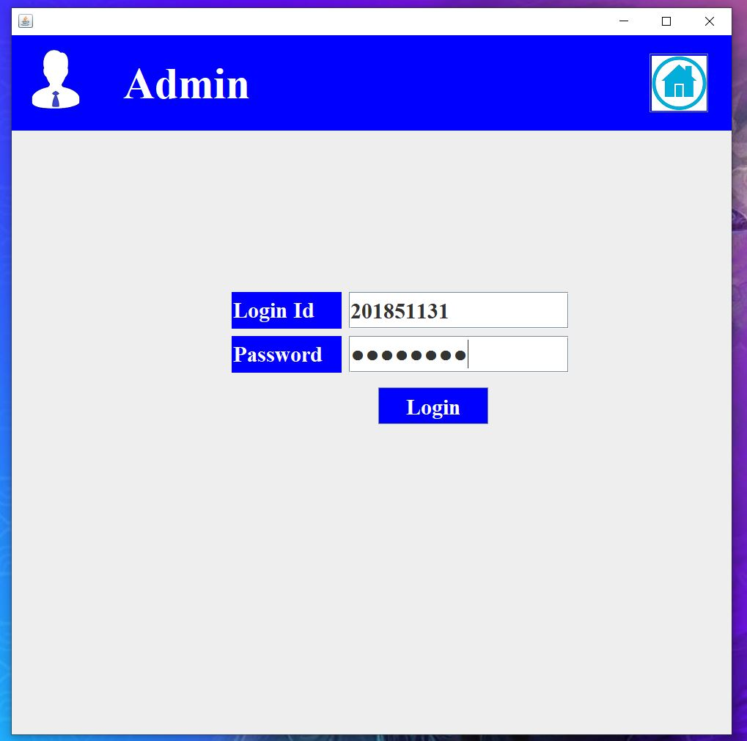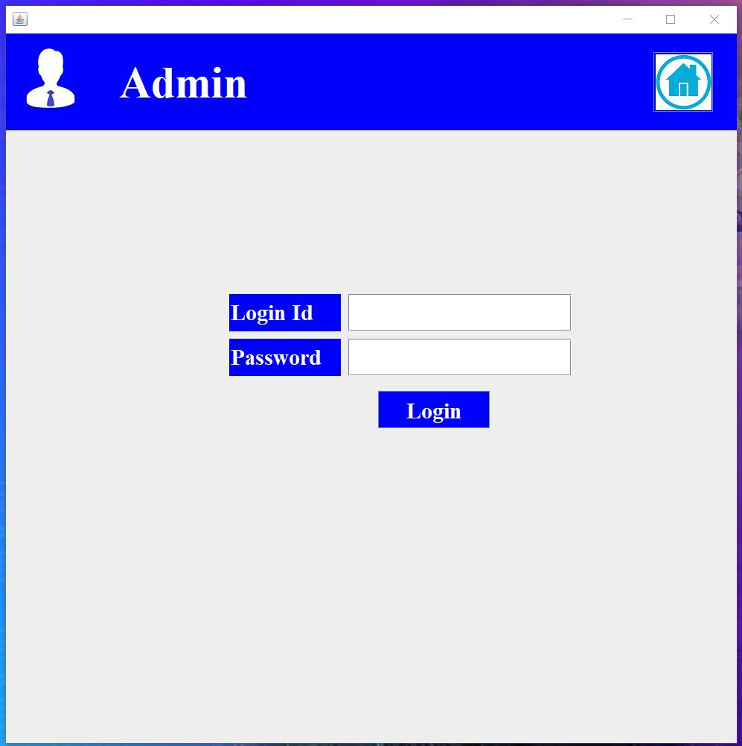**Screenshot of Admin Login Page**

**Screenshot of Admin page**

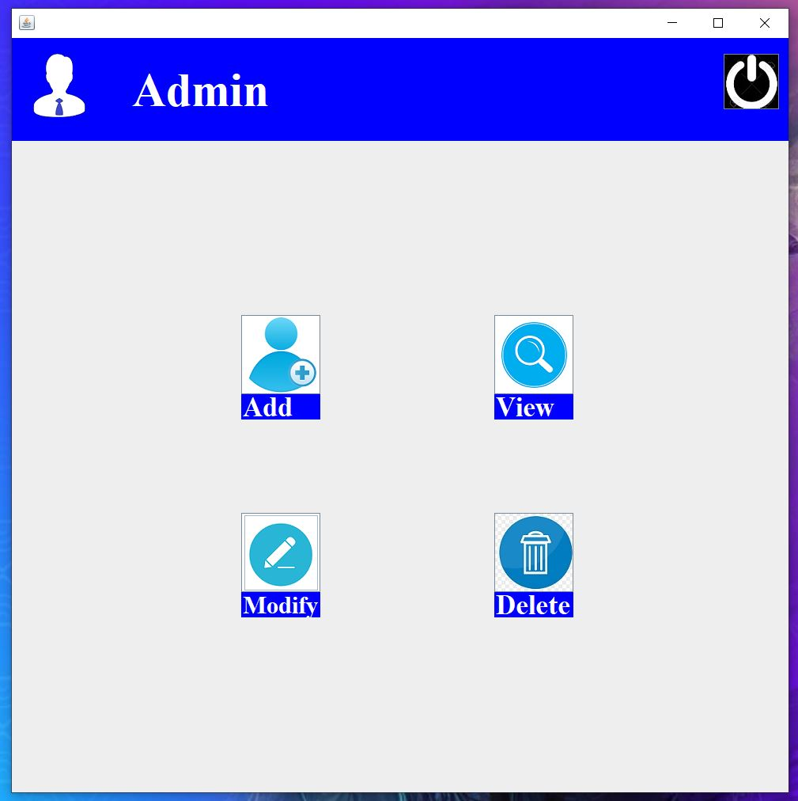

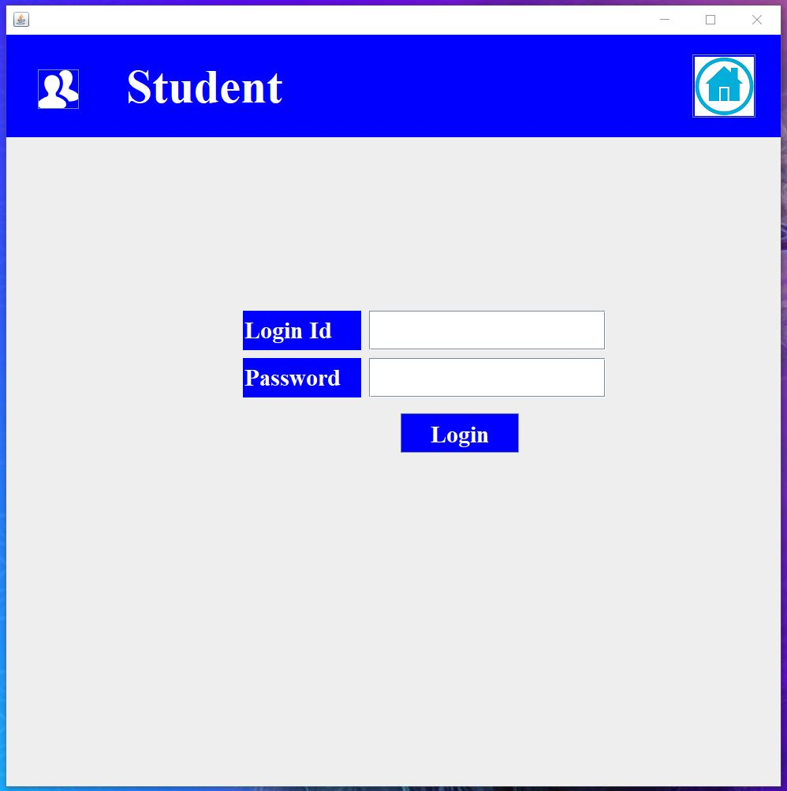**Screenshot of Student Login page**

**Screenshot of Student Page**

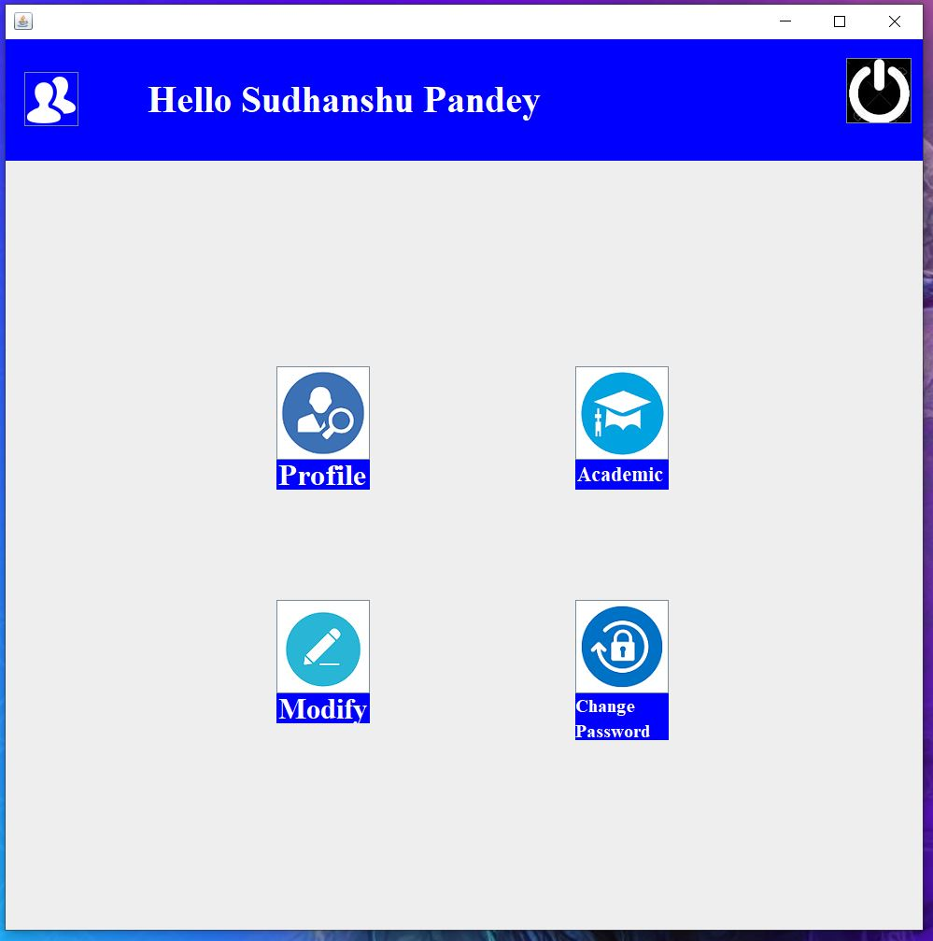

**Screenshot of Faculty LoginPage**

